Task2: Tag the Model Number in html pages

Framework: Flask (Python + JavaScript)

Run the Flask app as mentioned in readme.txt

Once the app is running, we will the page as depicted below

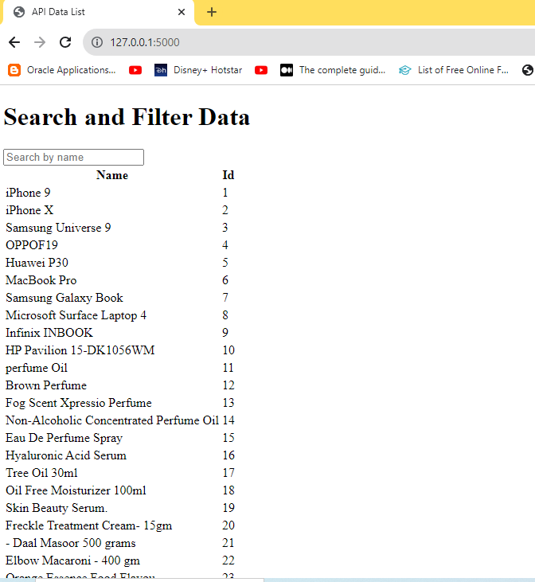

Output of the function should be start and end indexes of the model number in html

Let’s take an example

Starting letter I, ending letter r

We just enter **i**xxxr

Expected result: All the items starting with letter I and ending with letter R

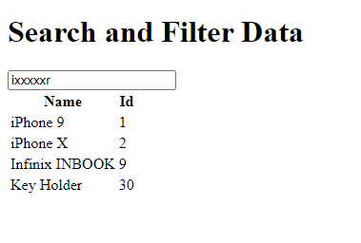

Similarly it will work for other combinations